AGENDA
Fish Passage Operation and Maintenance (FPOM) Team meeting
Fish Counting Task Group following FPOM
August 08, 2013 (0900-1400)
CRITFC new offices. 5th floor.
700 NE Multnomah St., Suite. 1200
Portland, Oregon 97232
Conference line: 888-675-2535 Accesss/Security code: 4849586

- Approve July 2013 FPOM minutes. (Klatte)

- Action Items
  - NWW Action Items.

  - NWP Action Items
    - [Feb 13] BON AFF PIT tag detector. ACTION: Fryer will have detailed drawings, an operating plan, and monitoring plan for FPOM review in October.
    - [Jul 13] BON JMF Separator Bar contract and condition sub-sampling. ACTION: Klatte will arrange for a meeting between FPC and BPA.
    - [May 13] BON video Kelt Monitoring. ACTION: NWP (FFU) will develop a proposal for kelt monitoring from 1 March through 10 April. They will bring this back to FPOM in August or September for further discussion and development.
    - [Jul 13] AFF modifications/mortalities. ACTION: NWP will look at the potential of installing cameras.

  - Action Items completed or to be discussed later in the agenda.
    - [Jul 13] AFF lamprey morts. ACTION: Zorich will bring recommendation to Corps-Tribal Accords Work Group next week as well as seek input from Sean Tackley (NWP Planning) and lamprey researchers trapping lamprey in the AFF. STATUS: Potential to raise AFF picketed leads by 1.5" to prevent AFF mortality. Group was uncertain this would be beneficial since not all picketed leads are down during AFF sampling. This would also route fish around the AFF Upper trap which is the main source of lamprey for research and translocation and so could hamper collection efforts.

- Updates
  - NWW Updates
    - MCN model. We have indeed been using the model, as the sawtooth pattern is mandatory under the current FPP. We have been working the sawtooth model around the units that have been out of service for rewinds and other work. Also, when units are shut down briefly due to low power loads, the operators have been using the sawtooth pattern as determined by the model and by the current FPP. We also used the sawtooth pattern to determine the order of the units that were shut down for recent RAS and Doble testing. The use of the model is probably partly responsible for the fact that we have not had any significant fish mortalities this summer due to temperature shock.
    - MCN sampling without transport.
    - IHR Line 1 disconnect maintenance (MOC 13IHR11 to be revised and resubmitted.)
    - LWG adult fish passage and water temperatures
    - Juvenile fish transport – end of barging nearing
  - NWP Updates
    - BON mid-season fishway ROV inspection.
    - BON fish unit ROV inspection.
    - BON temps- modified sampling for the JMF and AFF.
    - BON Updated Dewatering Plans.
    - TDA mid-season fishway ROV inspection.
    - JDA mid-season fishway ROV inspection.
    - JDA fish pump #2.
    - JDA temps- modified sampling for the SMF.
  - Research/FFDRWG updates. Approval letters, permits, etc located at www.nwd-wc.usace.army.mil/tmt/documents/FPOM/2010/NWP%20Research/Research.html
    - AFF mortalities.
  - RCC update.
Project | Previous day average (kcfs) | 5 day forecast average (kcfs) | 10 day forecast average (kcfs)
LWG
MCN
BON
  - Lamprey updates.
    - BON WS lamprey structure.
    - JDA-S Lamprey collection temperature protocols. At this time we could find no literature values to help guide in deciding an appropriate temperature limit, above which the trap should not be operated. We reviewed five years (2008-12) of trapping data for John Day Dam provided by Aaron Jackson (CTUIR). The mean mortality rate was 0.8% over a temperature range from 14.8 to 22.8 C (58.6 to 73.0 F) and there was no relation between mortality and water temperature (WQM tailrace). Therefore we ask trap operator to collect water temperature at the trap to help us determine an upper thermal limit.
  - Avian.
  - Critical Infrastructure. No update in August 2013.
  - BPA updates.

- Coordination/Notification forms (need concurrence).
  - 13BON51 Washington Shore Lamprey flume repairs
  - 13LGS08 – Rescheduling of Doble Testing

- Fish Passage Plan: The Draft 2014 FPP and Change Forms website is at: http://www.nwd-wc.usace.army.mil/tmt/documents/fpp/2014/changes/index.html. All change forms reviewed to date have been posted. See the “Production Schedule & Deadlines” document for a timeline of events and due dates for change forms to be included the printed version of the 2014 FPP:
- Friday, 01 NOV 2013 – all Corps change forms due to Wright.
- Friday, 13 DEC 2013 – all change forms due to Wright.
- Tuesday, 31 DEC 2013 – final draft sections and change forms will be posted online for regional review.
- Appendix A (Special Project Operations and Studies) sections will be drafted by NWW and NWP as soon as final study designs and operations are finalized (via FFDRWG and/or FPOM), and are due to Wright by mid-February for inclusion in the final print version of the 2014 FPP.
  - 14BON001 PH2 Mid-Range Operation. Pending NWD policy/legal review.
  - 14BON005 6.6. navlock dewatering verbiage
  - 14BON006 facts and figures
  - 14BON007 avian and pinniped hazing
  - 14TDA004 6.6. navlock dewatering verbiage
  - 14TDA005 facts and figures
  - 14TDA006 avian and pinniped hazing
  - 14JDA002 6.6. navlock dewatering verbiage
  - 14JDA003 2.2.1. TSW removal
  - 14JDA004 facts and figures
  - 14JDA005 avian and pinniped hazing

- Potential 2014 FPP changes.
  - Fredricks suggested including a calendar of dates when specific actions are scheduled to occur.
  - All Projects: Adult salmon diel passage data added to guide decision-making during scheduling of O&M activities. FPP location to be determined. Proposed at FPOM June 13.
  - JDA: JDAS lamprey trap operations in Lamprey Appendix.
  - MCN: Debris spill protocol prior to TSW removal. Proposed at FPOM June 13.
  - MCN: remove language regarding transportation.
  - LGS TSW: add criteria that SW will be closed no earlier than August 1 to ensure closure doesn’t occur during subyearling migration. If low-flow criteria are achieved prior to August 1, the TSW will remain in service until August 1 unless an adult passage delay is observed or if necessary due to turbine unit operational constraints at low flows. Closing the TSW prior to August 1 will be coordinated with FPOM via an MOC.
  - Appendix B: remove language regarding MCN transport.
  - Appendix or new section: Guidelines for Avian & Pinniped Hazing. Proposed at FPOM April 11 and May 9.
  - Lorz requested project stats, such as number of turbine units, MW, max/min forebay, etc.

- Task Group Updates.
  - Fish counting task group (Setter). Team members include Fredricks, Klatte, Mackey, Setter, Tackley, and Wills. Setter pulled together existing needs and gave that to Klatte. A meeting will be tentatively scheduled for after the August FPOM. Setter suggested there may be a place for video counting at some projects. The team can look at all of the options.
  - Avian task group. Chaired by NWW. Team members include: Cordie, Dugger, Fone, Fredricks, Hausmann, Madson, Setter, Skidmore, Trachtenbarg, Zorich, Zyndol. NWW will hold a meeting after the September FPOM. Zorich asked about the objectives of this task group. He noted that there is some disproportionate allocation of lethal take in the Basin. Fredricks suggested going dam by dam and looking at the effectiveness of our avian abatement program at each project. Klatte suggested bringing in the Port of Portland avian guy as well.
  - AFF mods (Rerecich). Modifications are not complete so task group will continue.
  - Sea Lion task group. (Stansell). Team members include: Fredricks, Conder, J. Skidmore, Hausmann, Mackey, Whiteaker, VanderLeeuw, Cordie.

- Calendar items/ next FPOM agenda items. (Check the CY13 on the website)

Memorandums of Coordination
☺☺☺☺☺☺☺☺☺☺☺☺☺☺☺☺☺☺☺☺☺☺☺☺☺☺☺☺☺☺☺☺☺☺☺☺☺☺
☺☺☺☺☺☺☺☺☺☺☺☺☺☺☺☺☺☺☺☺☺☺☺☺☺☺☺☺☺☺☺☺☺☺☺☺☺☺
COORDINATION TITLE- 13 LGS 08 Rescheduling of Doble Tests
COORDINATION DATE - August 2, 2013
PROJECT - Little Goose Lock and Dam
RESPONSE DATE - August 15, 2013
Description of the problem Little Goose Dam Main T1 Transformer “Doble” testing was tentatively scheduled for August 5–15, 2013 (FPP Appendix A, Page A-19, Special Project Operations section 1.6 Doble Testing). Doble testing will not take place as planned for 2 reasons.
- The BPA has determined that a transmission line circuit breaker at the Little Goose substation has failed. For practical reasons, investigation into the cause of this failure and the subsequent replacement of the circuit breaker is necessary prior to the start of Doble Tests. This work is scheduled to take place during the same August 5-15 time frame as the previously planned Doble Tests.

- The Lower Granite line outages in support roof replacement and Doble Tests in August precludes the possibility of Doble Tests at Little Goose. Little Goose and Lower Granite Dams share the same transmission lines. One of these facilities must be in service to ensure the transmission lines remains energized. Should these transmission lines go out of service, the integrity and reliability of the regional power grid and continued electrical service to local utilities will be compromised.

The next available work window from BPA, Inland Power, project staff and the testing engineer is September 9 – 12, 2013. This date is the last available work window for this year. If not rescheduled, this work will not be completed and important equipment testing will not be conducted, resulting in WECC/NERC compliance issues. Non-compliance may force equipment shut down and the loss of generation capacity. For safety reasons, Doble Testing must be conducted during dry weather. Postpostment of these tests into the Fall and Winter months is not feasible. Doble testing is required to validate transformer operational conditions. Not performing the tests will put at risk transformer operational integrity and powerhouse reliability.
Type of outage required Doble testing for T1 Bank will require a total powerhouse outage, and 100% spill (except for station service) for up to 6 hours on September 9. By then, all preliminary work should be completed and T2 re-energized allowing generation availability of Units 5 and 6. T1 and turbine units 1 through 4 will be removed from service on September 9 from 0700 hours to September 12 at 1700 hours. Turbine unit 1% efficiency operations and turbine priorities will continue to follow fish passage plan requirements during this work. Another total plant outage lasting approximately 2 hours, will be required on the last day of the outage Sept 12th to remove clearance tags and restore T1 bank service. Because of the time and effort required, placing T1 in and out of service on a daily basis is not a practical option.
Impact on facility operation Total powerhouse shutdown is required for up to 6 hours while T1 is taken out of service on September 9 and for approximately 2 hours on September 12 when T1 is returned to service. During these periods, turbine unit 5 will be operated under speed-no- load conditions for station service. Under these conditions, approximately 5 kcfs will pass through the turbine and the remainder of river flow will be spilled. All adult fishway pumps will be available for service (pump #3 is expected to be back in service by August 9). The juvenile fish facility will continue to operate with diesel generator supplied electrical service.

Only turbine units 5 and 6 will be available for operation during the T-1 line outage. Since turbine units 5 and 6 require slightly more flow to operate, one can expect slightly less spill (should spill take place) than if turbine units 1, 2 or 3 were available for service. Spill required under the Fish Operations Plan (FOP) will end on August 31.
Dates of impacts/repairs September 9 – 12, 2013
Length of time for repairs September 9 – 12, 2013
Expected impacts on fish passage
Adult Fish Impacts: Turbine units 5 than 6 would become operating priority units from September 9 to 12. This outflow pattern may intensify the counter-clockwise eddy at the powerhouse tailrace area. Adult fish guidance and attraction to the south shore entrances may be reduced and fish passage may be delayed. Project staff will monitor fish passage closely, if fish passage appears to be delayed, the project can offset these effects by increasing fish pump output to enhance outflow from the adult fishway entrances. The project can also manipulate flow patterns between Spill and Turbine units during the morning hours 0600 – 1000 hours during the highest fish passage times of the day increasing the attraction flows where needed. This availability of attraction capability should offset any problems associated with the changes incurred by the Unit outages. These capabilities would be coordinated through FPOM and RCC if needed to enhance passage needs.

Juvenile Fish Passage Impacts: Fish will be entering the upper end of the collection gallery where juvenile fish are known to hold at times. Auxiliary diesel generator power will be available at the collection facility. PIT tag detection, fish collection, and sampling will continue as usual.

Potential Mitigation Actions:
Operate spillbay 8 to minimize clockwise eddy on right bank of river to improve adult fish attraction to north shore entrances. Spill may shut down at night to maximize juvenile fish collection.
Operate all 3 fish pumps, and manipulate sluice way gates and diffusers to optimize attraction flow at the south shore entrances. Could also manipulate the water supply to maximize attract at the north powerhouse and north shore entrance. However, too much water in the downstream end of the collection channel will slow channel velocities.
Fish Passage Historical Data
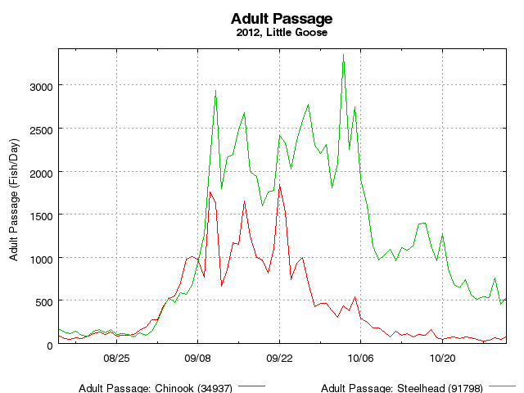

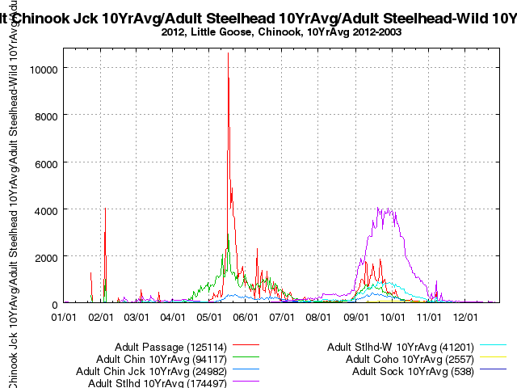

Little Goose Adult Fish Migration -10 Year Average 2003 - 2012
Dam | PassDate | ChinookAdult | ChinookJack | Steelhead | Unclipped Sthead | CohoAdult | CohoJack
LGS | 9-Sep | 606 | 227 | 1869 | 442 | 8 | 2
LGS | 10-Sep | 757 | 281 | 2168 | 514 | 13 | 3
LGS | 11-Sep | 759 | 336 | 2517 | 596 | 19 | 5
LGS | 12-Sep | 586 | 280 | 2777 | 638 | 20 | 3

Little Goose Adult Fish Migration - 9/9-9/12, 2010-2012.
Date | Adult Chinook | Jack Chinook | All Steelhead |  | Unclipped Steelhead |  | Adult Coho |  | Jack Coho
9/9/2012 | 768 | 370 | 1266 |  | 421 |  | 12 |  | 2
9/10/2012 | 1762 | 828 | 2127 |  | 634 |  | 24 |  | 10
9/11/2012 | 1626 | 944 | 2942 |  | 799 |  | 58 |  | 28
9/12/2012 | 667 | 379 | 1793 |  | 486 |  | 34 |  | 6
9/9/2011 | 536 | 203 | 1350 |  | 310 |  | 17 |  | 7
9/10/2011 | 582 | 190 | 1637 |  | 360 |  | 29 |  | 2
9/11/2011 | 922 | 233 | 2062 |  | 496 |  | 30 |  | 6
9/12/2011 | 779 | 240 | 2189 |  | 510 |  | 42 |  | 10
9/9/2010 | 1716 | 271 | 2787 |  | 769 |  | 20 |  | 2
9/10/2010 | 1655 | 300 | 3435 |  | 934 |  | 16 |  | 2
9/11/2010 | 1609 | 266 | 4323 |  | 1159 |  | 40 |  | 7
9/12/2010 | 904 | 126 | 4296 |  | 1140 |  | 36 |  | 1

Comments from agencies
From: Bill Hevlin - NOAA Federal [mailto:bill.hevlin@noaa.gov]
Sent: Friday, August 02, 2013 12:53 PM
Subject: Re: Coordination Request - 13 LGS 08 Rescheduling of Doble Tests

John,
Thank you for the timely coordination on this date change for the Doble testing at Little Goose. As you mention, the change in unit priority to units 5 and 6 on September 9 to 12 will reduce powerhouse tailrace conditions conducive to adult salmon and steelhead locating the south shore ladder entrances, likely resulting in tailrace migration delay over that time period. You also mention that there may be alternative powerhouse and spillway flow operations during the morning hours on those days which may aid adult location of the north shore ladder entrances. We will need to examine the FPP uniform spill pattern (no ASW) to see whether adjustment to a crown pattern might be better for attraction to the spillway entrances, and, as well, discuss flows through units 5 & 6.

I don't know the state of the Little Goose general model at ERDC, or whether there are resources available for a short study there, but that would likely help the Corps develop the best alternative operation given these constraints. I fully support your recommendation to discuss this coordination request on August 8 at the FPOM meeting, where the committee could help the Corps develop a viable plan to facilitate adult passage.

Bill Hevlin
NOAA Fisheries

-----Original Message-----
From: Bailey, John C NWW
Sent: Monday, August 05, 2013 8:48 AM
To: 'Bill Hevlin - NOAA Federal'
Bill:

By the time September rolls around, I don't think there will be enough water to create a true crown pattern. Total river flows last year during the September 9-13 time period ranged between 23 and 25 kcfs and this year flows will likely be even less. Assuming unit 5 or 6 will take 15 - 18 kcfs to operate, that will leave 5 to 10 kcfs for spill which means 6 stops or less of spill for most of this period. In generally, we will be spilling @ 20 kcfs for up to 6 hours on September 9 and up to 2 hours on September 12. For the most of the September 9 -12 time period, all river flow will likely be directed through units 5 and/or 6.

Sean Milligan, our hydraulic engineer who is most familiar with Little Goose flow patterns and the ERDC model says the safest course of action is to stick with the prescribed flat non-TSW spill pattern in the Fish Passage Plan. This pattern will lower the possibility of eddys forming in the tailrace which may impede fish adult passage. A crown pattern will only increase the possibility of eddy formation in the tailrace. A "crown pattern" given the small amount of spill for most of this work window won't likely create a tailrace pattern much different than the flat spill would since only 5 or 6 stops are involved at the most.

John B.

-----Original Message-----
From: Bettin,Scott W (BPA) - KEWR-4 [mailto:swbettin@bpa.gov]
Sent: Monday, August 05, 2013 9:04 AM
To: Bailey, John C NWW; Bill Hevlin - NOAA Federal; BPA Bill Berry
Subject: RE: Coordination Request - 13 LGS 08 Rescheduling of Doble Tests

During September we normally don't spill so any flow outside the hours when the line is out of service will be going through units 5 and 6 if they are available. During the line switching outage the spill level will most likely be 6.5 kcfs since we are outside of the MOP period and we will be able to use the pool to shape the water. -s
Final results
☺☺☺☺☺☺☺☺☺☺☺☺☺☺☺☺☺☺☺☺☺☺☺☺☺☺☺☺☺☺☺☺☺☺☺☺☺☺

